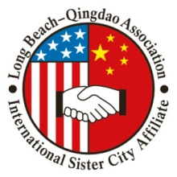
Long Beach - Qingdao Association
A Sister City of Long Beach
2025 Lunar Calendar New Year ArtBook
Artwork Submission Form
Please complete the following form for the images you submit. The theme of the artwork shall be the Lunar New Year celebration of your city
Name to displayed in book | Email Address | Website | Telephone Number (will not be displayed) | Mailing Address  (will not be displayed)
File Name | Artwork Name | Media | Size in inches or cm | Year Created

* Please note:

Artwork Details: Provide the name of the piece, the media used to create the work, the size of the work, and the year created.
- Example: 3 Flowers, Digital Photography, 12” x 5”, 2023
Image File Size: Submit publication-quality images only, 300 dpi, no less than 2500 pixels in width, nor less than 3500 pixels in height.
The Artist hereby certifies that the artwork submitted is the artist’s original work. The artist also hereby grants Long Beach-Qingdao Association and its project management collaborators permission to showcase the works online, in physical exhibits , or in any fashion the LBQA sees appropriate to foster its mission
________________________________________ ________________________________________
Artist Signature Artist Parent Signature (if artist under 18)
________________________________________ ________________________________________
Artist Name Artist Parent Name (if artist under 18)
Date ____________________________
“Save As” and include your name in this submission form
Please send this file and artworks to:longbeachqingdao@gmail.com

